HOLIDAY HOME REGULATIONS
Being compliant with the Vacation Rental Regulations is a fundamental requirement. Failure to comply with the detailed points below may result in a penalty, such as loss or reduction of the amount paid as a deposit.

- GENERAL REQUIREMENTS

- All guests (and any other visitors) must comply with all House Rules and any other instructions of the Property Manager Cozy Apartments during their stay;
- Guests are required to notify the Property Administrator of any discussion or complaint by neighbors as soon as possible.


- NOISE AND NEIGHBOURHOOD

- This Holiday Home is suitable for children
- Guests are fully responsible for the safety and security of their children at all times, as well as for any behavior that may disturb other residents in the neighborhood.
- Guests and Visitors must minimize noise so as not to disturb the occupants of neighboring properties - especially during the night hours (23:00 - 08:00).
- Excessive noise is prohibited at any time and can result in termination of the lease, eviction, loss of the amount paid for rent and an extra cost deducted from the amount paid as a deposit.
- Guests and Visitors must avoid any kind of disrespectful behavior and minimize their immediate impact on local residents.

3. VISITORS
- Guests are allowed to receive a maximum number of 2/3 visitors at any time during their stay (for a maximum of 4 people at the same time).
- Guests are responsible for not exceeding the maximum number of visitors, and for ensuring that they also comply with these Regulations.
- Any overnight stays of visitors must be approved in advance during the booking process and are subject to additional costs as indicated in the final price.


4. USING THE PROPERTY

- Parties and large gatherings of any kind are strictly prohibited within the Property;
- Any meetings with a small number of people must comply with what has already been detailed in terms of noise, neighbourhood and visits.

5. PARKING
- The apartment does not have a private parking lot, but there is a place for the car near the house (e.g. in the interchange parking lot of the Metro C -Giardinetti or in via degli Orafi )
- Guests and visitors are required to respect the signs and not create an obstacle to traffic, showing respect for neighbors and other cars

6. WASTE AND RECYCLING

- Guests and their Visitors will be responsible for Waste and Recycling in accordance with the customary practices of the Holiday Home (as detailed below), must use the appropriate containers, and must not leave excesses in common or public areas;
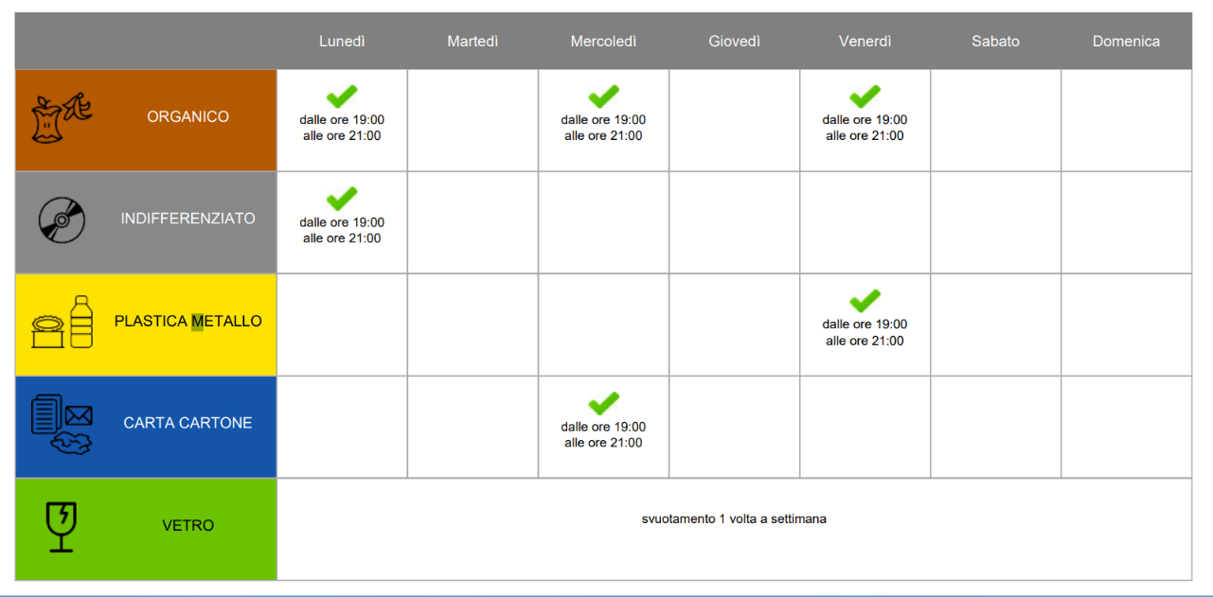
- The organization for the collection planned for Via Foppa is as follows:

Don't worry if you are not present on the indicated days, we will throw it away at the appropriate time, help us only by differentiating correctly.
The bags to be used
- Compostable bags for food and organic waste
- Non-opaque pouches for plastic and metal containers
- Non-opaque bags for non-recyclable waste
- Paper bags or bags without bags (never in plastic bags) for paper and cardboard
- No envelope for glass containers


- SAFETY

- Whenever Guests leave the Holiday Home, it is their responsibility to ensure that all windows and doors are closed/locked, in order to ensure the safety of the property and prevent rainwater damage.
- Guests must turn off gas, lights, air conditioning, fans, appliances such as television when they are not in use, in favor of energy saving.
- Guests must supervise infants and children at all times for their safety.

8. SMOKING

- Smoking is not allowed inside the Holiday Home. Failure to comply with this rule may result in a deduction from the deposit or, alternatively, a subsequent charge.


9. ANIMALS

Unfortunately, pets are not allowed in the Holiday House


10. DAMAGE AND BREAKAGE

- All damage and breakage must be reported immediately to the Property Manager.
- To avoid damage and breakage, it is advisable not to move furniture from one room to another without prior permission.
- It is forbidden to take towels away from the house for outdoor use. If necessary, special beach/pool towels will be provided (request with at least 1 day's notice).


14. CHECK-OUT PROCEDURE

The rules for key management, security, cleaning, waste, etc., are as follows:
    - The keys must be handed over to the administrator of the holiday home (or placed in an agreed place) by 10 am on the day of check-out
    - The house must be closed as per safety regulations
    - Waste must be stored as indicated


15. EMERGENCY CONTACTS

In the event of an emergency connected with the Holiday Home, the contact details are:
    - Anna 3886333042
    - Marco 3382031499
Per eventuali altre emergenze:
Numero unico emergenze 112
Emergenza sanitaria 118
Polizia di stato 113
Vigili del fuoco 115


16. REGULATION COMPLIANCE

- Failure to comply with any rule will result in a violation of the Terms and Conditions of the stay.
- The owner and the Administrator reserve the right to revoke the guests' ability to stay if they do not comply with the rules of this house or cause disturbance to neighbors and other residents of the community


17.PRIVACY

We remind you that we comply with the Privacy Policy and that, by law, your data will be transmitted to the Lodging Portal and to ISTAT for tourist flows.

